AIVES System Architecture
SWD392 team document · updated 6 October 2026

The short version
AIVES is one ASP.NET Core application split into three business modules. Students, lecturers and administrators all use a single React web app. Data lives in PostgreSQL, answer audio goes to object storage, and the speech and language work is done by outside AI services that we call through adapters.
The AI never gives a final grade. It suggests a score, and a lecturer confirms it.
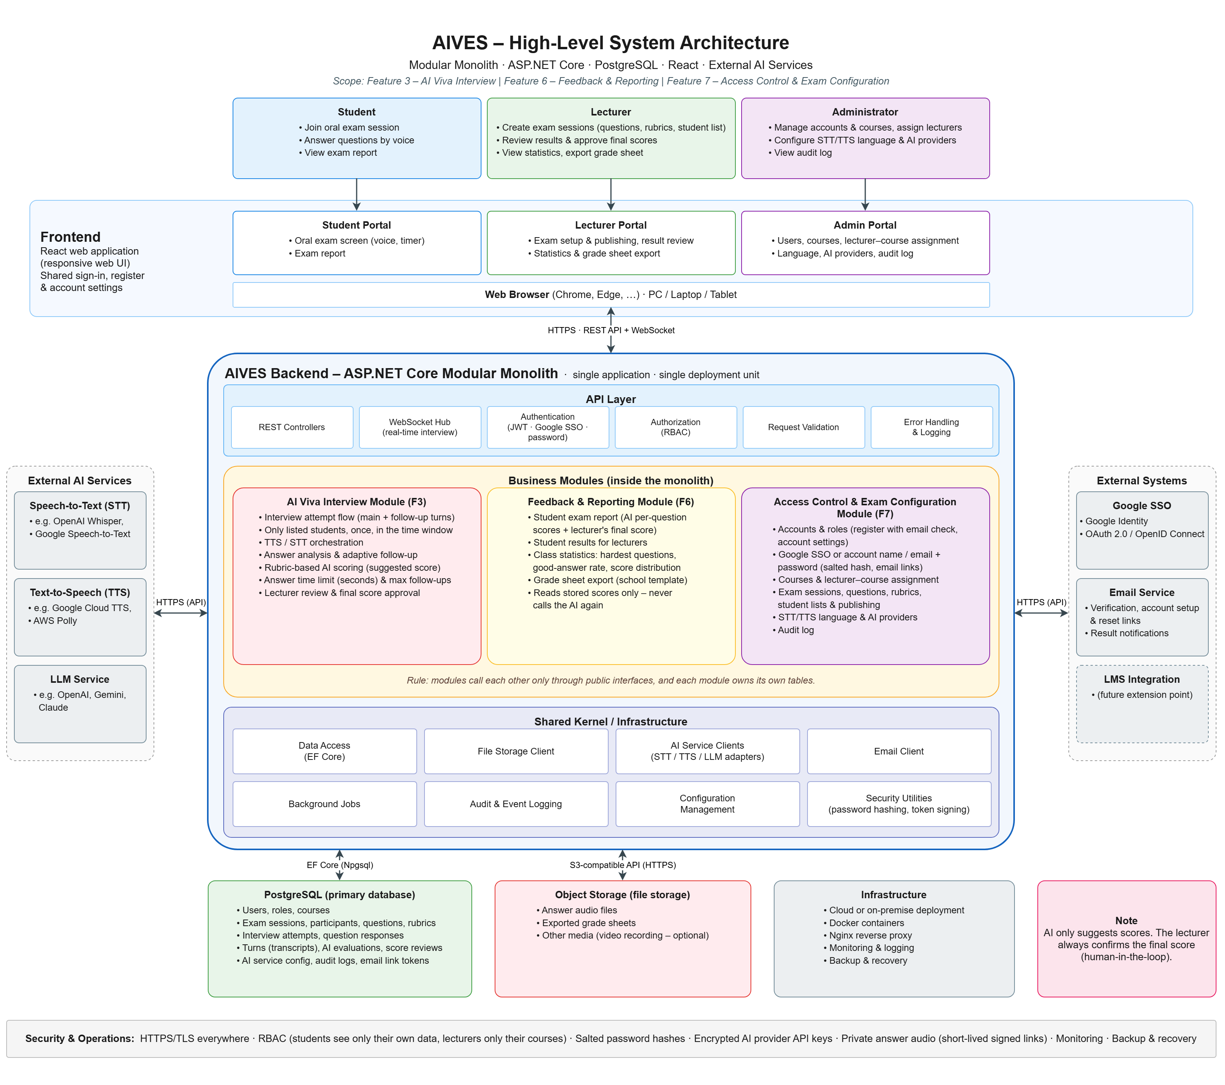
Figure 1. High-level architecture. Editable source: SystemArchitecture.drawio

1. What is in scope
We picked three features from the course feature list:
- Feature 3, AI Viva Interview: the oral exam itself.
- Feature 6, Feedback & Reporting: reports, class statistics and the grade sheet.
- Feature 7, Access Control & Exam Configuration: accounts (registration, sign-in, account settings), exam setup and AI settings. The course list calls this feature "System Administration"; our diagrams use a more specific name, as the lecturer asked.
Exam sessions, question lists and rubrics are built by our team. We do not take them from another team's module. LMS integration is out of scope for the first version: the architecture leaves room for it, but nothing is built.

2. Who uses it
Actor | Main tasks | Where
Student | Registers or signs in, joins an exam session that lists them (inside its time window, once), answers questions by voice, reads the exam report once the lecturer has confirmed the score. | Student Portal
Lecturer | Sets up and publishes exam sessions (questions, rubrics, student list, time window, answer time limit in seconds, follow-up limit), reviews transcripts, confirms final scores, views statistics, exports the grade sheet. | Lecturer Portal
Administrator | Creates accounts, changes roles and deactivates accounts; creates and edits courses and assigns lecturers to them; sets the STT/TTS language and the AI providers, reads the audit log. | Admin Portal

3. One answer, end to end
The easiest way to read the diagram is to follow a single answer through it.
- The student finishes speaking, or the answer time limit runs out, and the Student Portal sends the recording to the backend.
- The API layer checks the JWT and the Student role, then passes the request to the AI Viva Interview module.
- The module stores the audio in object storage and sends it to the STT service through the STT adapter. The transcript comes back as text.
- The module asks the LLM, through the LLM adapter, whether the answer is complete, and saves the transcript as a new interview turn in PostgreSQL.
- If the answer is unclear and the follow-up limit has not been reached, the LLM writes a follow-up question. TTS turns it into audio, the server pushes it to the portal over the WebSocket connection, and the loop starts again from step 1.
- Once the question is finished, the LLM scores the answer against the rubric. The score is stored as a suggestion until the lecturer reviews it.
Steps 3 to 6 call outside services, so this is the slow part of the system. It is where response time has to be measured once the providers are chosen.

4. Frontend
One React web application, responsive so it also works on tablets. It has three portals behind a shared sign-in, registration and account settings: Student, Lecturer and Admin.
Normal requests go through a REST API. The interview uses a WebSocket connection, because the server has to push the next question or a follow-up without the browser asking for it.
One constraint shapes deployment: browsers only allow microphone access on HTTPS pages (or on localhost), so every deployed environment needs HTTPS from the start.

5. Backend: a modular monolith
The backend is a single ASP.NET Core application, deployed as one unit and split into three modules. Three rules keep the modules apart:
- Each module owns its tables, and no module reads another module's tables.
- Modules talk to each other only through public interfaces inside the same process.
- Reporting reads stored scores and never calls the AI again.
Why not microservices: we are four people with one semester. One deployment means one thing to run locally, one build pipeline and one database. It also lets us save an interview turn, its evaluation and the attempt status in a single database transaction, which would need extra coordination across separate services.
What we give up: any change redeploys the whole backend, and a slow AI call could hold resources the other modules need. To limit that, AI calls are asynchronous and long-running work goes to background jobs.

6. The three business modules
Module | Does | Owns (entities in ConceptualERD.drawio) | Depends on
AI Viva Interview (F3) | Runs the exam: questions, answers, follow-ups, AI score suggestions, lecturer review. | INTERVIEW ATTEMPT, QUESTION RESPONSE, INTERVIEW TURN, AI EVALUATION, SCORE REVIEW | Configuration module (questions, rubrics, limits, participant list, AI settings); STT, TTS and LLM adapters; email client
Feedback & Reporting (F6) | Student reports, results per student, class statistics, grade sheet export. | None. It only reads. | Interview module (stored scores); configuration module (students, courses, sessions, questions, participant list, lecturer assignments)
Access Control & Exam Configuration (F7) | Accounts (registration, sign-in, account settings), courses, lecturer–course assignment, exam sessions, questions, rubrics, student lists, publishing, AI settings, audit log. | USER, ROLE, EMAIL LINK TOKEN, COURSE, EXAM SESSION, QUESTION, RUBRIC, PARTICIPANT, AI SERVICE CONFIG, AUDIT LOG | Google SSO, email service

PARTICIPANT belongs to the exam configuration module because the lecturer prepares the student list together with the session. The interview module uses it only through the configuration module's interface: it checks that a student is on the list before an attempt starts, and reports when the attempt starts and ends, which updates the participant's status.

AI Viva Interview
Section 3 shows how one answer moves through this module. On top of that, the module stops the recording when the student submits, when the answer time limit (in seconds, follow-up answers included) runs out, or when the session ends; counts follow-ups per question, and reads questions and rubrics from a published session. A published session is locked, so a grade can always be traced back to the exact question and rubric that were used. Only students on the session's participant list can start an attempt, only inside the session time window and only once. When the window ends, the session closes, attempts in progress stop at once and unanswered questions count as 0 (a question the student never reached has no stored response and simply adds 0 to the total). If the start check fails, the student sees the reason and no attempt is created. The lecturer confirms one final score per attempt. It starts as the total of the AI's per-question scores, and the lecturer may change it and add a comment before confirming.

Feedback & Reporting
Students see their report only after the lecturer confirms the final score; before that, the report says it is waiting for review. The report labels each per-question score as the AI's suggestion and shows the lecturer's final score for the whole attempt next to it, because the lecturer confirms one score per attempt. Lecturers see each student's results and three class statistics: the hardest questions, the good-answer rate and the score distribution. The grade sheet follows the school template. The grade sheet and the score distribution use confirmed final scores only, and attempts still waiting for review are marked as pending. The hardest questions and the good-answer rate use the AI's per-question scores, counted only for confirmed attempts.

Access Control & Exam Configuration
Users sign in with Google SSO or with their account name or email plus password. Only active accounts can sign in. Anyone can register with an account name, email and password; the new account is a Student, must confirm its email through a link, and is not linked to Google. On the first Google sign-in the system creates the account (Student, linked to Google, username from the part of the email before @) and asks whether to create an account name and password now; if yes, an email link opens a form for both, otherwise the user signs in with Google only until they create them in Account Settings. Accounts created by an administrator get an email link to set the account name and password. Account Settings also change the username (which, unlike the account name, can change and need not be unique) and link Google to an account whose email matches. A user who forgets their password asks for a link, and the system shows the same message whether or not the email is registered, so nobody can use the form to find out who has an account. The two kinds of link do different things: a reset link only sets a new password and never changes the account name, while an account-setup link sets both. An account that has a password gets a reset link; an account without one yet gets an account-setup link, so an expired setup or verification link can always be replaced.
Passwords are hashed with PBKDF2 (built into .NET) and a random salt per user. Only the salt and the hash are stored. Every email link (email verification, account setup, password reset) expires and works once.
Administrators create courses and assign lecturers to them. A lecturer sets up a session for one of their courses, starting with its time window: imports the question list, defines a rubric per question, imports the student list the same way as the question list (rows that match no account are skipped and reported), and sets the answer time limit in seconds and the follow-up limit. The session can be published only when it has at least one question, every question has a rubric and at least one student is on the list. A draft can be opened again later to finish the setup.

7. Shared kernel
Code that every module needs lives in one place instead of being rewritten three times:
- Data access with EF Core.
- A file storage client for object storage.
- Adapters for STT, TTS and the LLM, so changing a provider does not touch module code.
- An email client, background jobs, audit and event logging, and configuration.
- Security helpers for password hashing and token signing.

8. External services
Service | Used for | Candidates (not chosen yet)
Speech-to-Text (STT) | Turning answer audio into text | OpenAI Whisper, Google Speech-to-Text
Text-to-Speech (TTS) | Reading questions and follow-ups aloud | Google Cloud TTS, AWS Polly
LLM | Checking answers, writing follow-up questions, suggesting rubric scores | OpenAI, Gemini, Claude
Google SSO (Google Identity) | Sign-in with Google accounts (OAuth 2.0 / OpenID Connect) | Fixed: Google
Email service | Email verification, account setup and password reset links; result notifications | Not chosen

All of these run outside our backend and are called over HTTPS. Administrators pick the active STT, TTS and LLM provider in the Admin Portal. A provider we have not used before needs a new adapter, but no change to the modules.

9. Where data is kept
- PostgreSQL, through EF Core and the Npgsql provider, holds the 15 entities in ConceptualERD.drawio. The data is relational (sessions, attempts, turns, scores), which is what PostgreSQL is built for.
- Object storage (S3-compatible) holds answer audio and exported grade sheets. The database keeps only the file URL and metadata, so backups stay small and audio can be served straight from storage.

10. Security
- HTTPS everywhere, which the microphone needs anyway.
- Role checks on every API call: students see only their own attempts, lecturers only their assigned courses, and only administrators change configuration.
- Salted password hashes, and email links (verification, account setup, password reset) that expire and work once.
- AI provider API keys are stored encrypted.
- Answer audio stays in a private bucket and is served only through short-lived signed links, after the role check.
- Scores need a person: the AI suggests, the lecturer confirms.

11. Deployment
The backend runs in Docker containers behind an Nginx reverse proxy, which also handles HTTPS. Monitoring, logging, backup and recovery are part of the plan, but the tools are not chosen yet.

12. Not decided yet
These points are open. We list them so nobody reads the diagram as more settled than it is:
- Which STT, TTS and LLM providers to use.
- Which email service to use.
- How long a student may wait between finishing an answer and hearing the next question. The team's non-functional requirements only say "fast enough", so we still need a number to test against.
- The file format of the grade sheet export. We only know it must follow the school template.
- Hosting: cloud or on-premise.
- How long answer audio is kept. We will ask for the school's rule.
- Enrolling students in courses. Today the lecturer imports a student list for each session; enrolment would add a student–course relationship.

13. Related files
These files sit in the same folder as this document:
- Use cases: UseCaseDiagram.drawio
- Workflows (9 swimlanes): SwimlaneDiagram.drawio
- Data model: ConceptualERD.drawio and ClassDiagram.drawio
- Architecture: SystemArchitecture.drawio, exported as SystemArchitecture.png for slides
- Feature list: AIVES - Feature Description (EN).md

